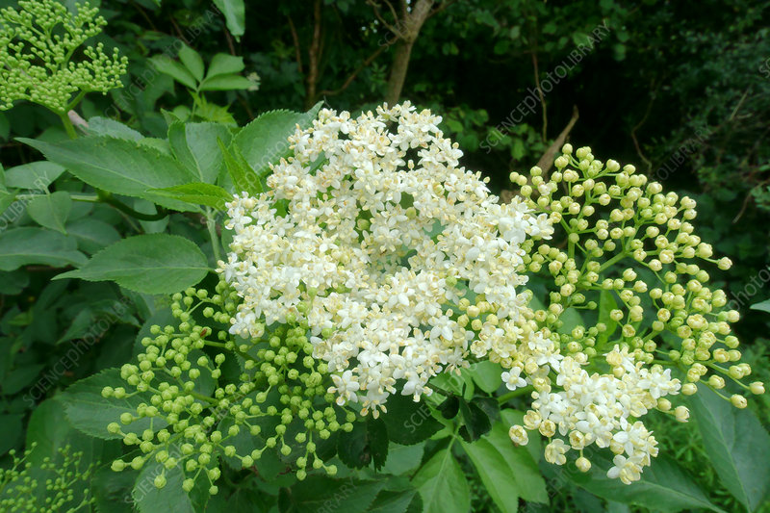Elderberry Flower Bracts

Health Benefits from WebMD
- High in Antioxidants & Vitamin C
- Inflammation tamer
- Lessens stress & protects heart
- Reduces duration and severity of cold and flu symptoms (U.S. NIH study)

Growing Sambucus canadensis
-Partially self-fruitful; two or more cultivars for better fruit production
-Site Selection: woodland edge plant conditions, full sun/part shade, rich loamy soil with good drainage (supplemental watering in drought). Wind tolerant, great for a hedge row.
-Planting: 2 metres apart
-Pruning: in late winter; dead wood, oldest growth can be heavily pruned to revigorate
-Propagating: from stem cuttings
-Harvesting: flower bracts (early summer), purple berries (late summer)
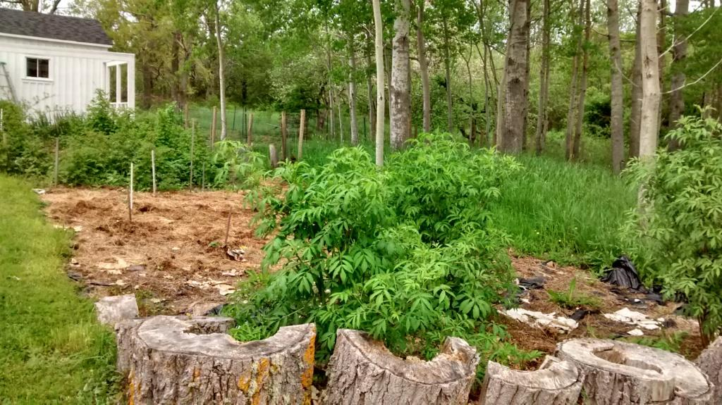
Summer 2019
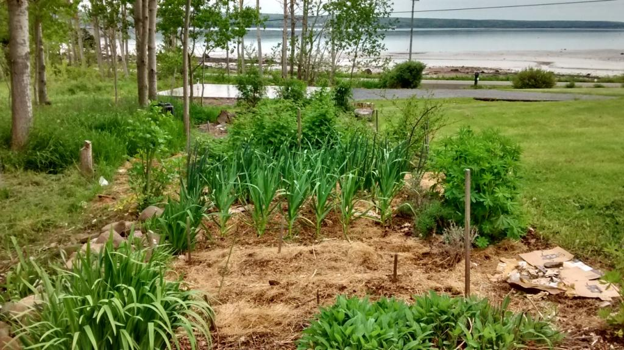
Fall 2020
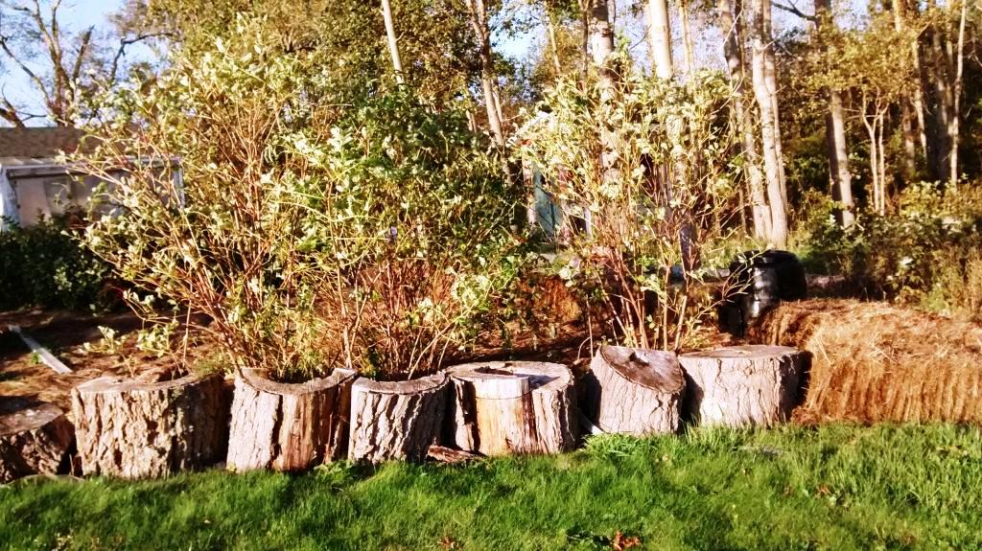

Utilizing
- Flowers can be harvested for drinks or fritters
- Pick berries when deep purple, separating stems from fruit (freeze first to aid stem removal). Use in: wine making, cordials, jams, jellies, pies. Freeze or dry.
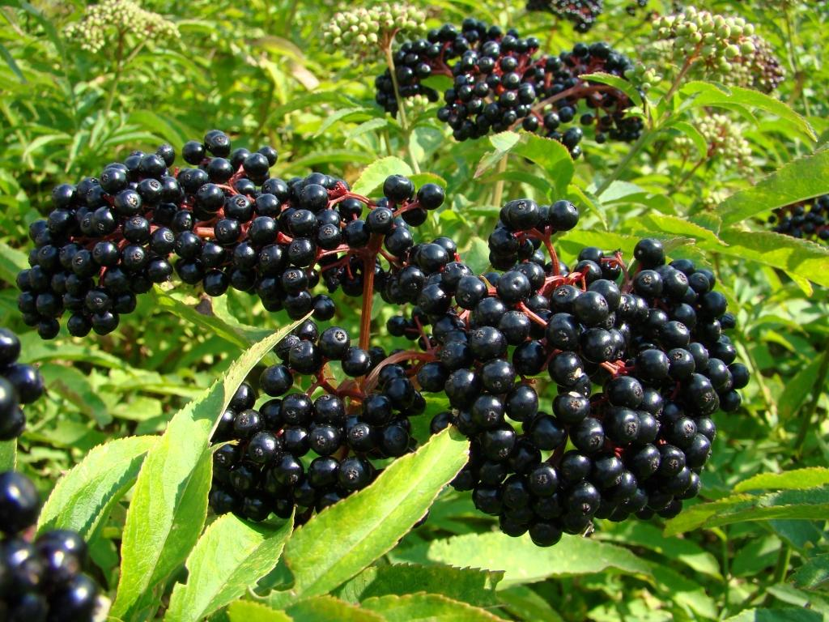

Recipes & Resources
Plants available at Briar Patch in Berwick or order stem cuttings from me.
YouTube “Off Grid with Doug & Stacy,” featuring Terry Durham of River Hills Harvest video on propagating and tonic making.
++++++++++++++++++
Cordial
1 quart berries
1 quart water
2 cups sugar
1 Tbls. lemon juice & rind of ½ lemon
Cook berries in water with rind 30 min., skim froth. Strain and return to pan with sugar and lemon juice; heat gently until sugar dissolved. Bottle in sterilized jars. ++++++++++++++++++++++++++
Elderberry Liqueur
Place berries in jar and add brandy and vodka to cover. Leave some headspace as liquid may bubble over. Store in dark cupboard for 3 months, shaking daily for one week, and then occasionally (at least weekly). Strain, add sugar syrup to taste, bottle and age for three more months. Enjoy!

